Reynold’s Southern Duck Pond
Management Plan

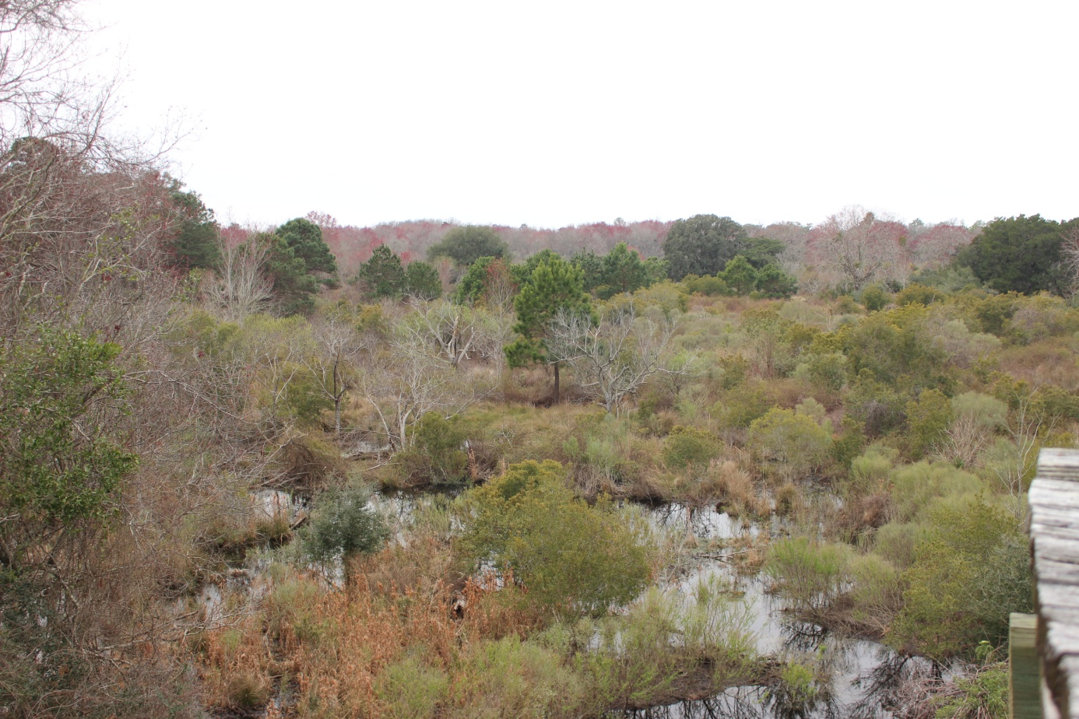
Sapelo Island, GA
Senior Project 2015
Joseph Woods and Allison Gordy
5/4/2015

TABLE OF CONTENTS

Problem Statement………………………………………………………..3
Introduction……………………………………………………….............3
Client Description………………………………………………...3
Client Objectives…………………………………………….…...3
Site Description…………………………………………………..5
Site History………………………………………………….........5
Materials and Methods…………………………………………………...7
Sampling Procedures……………………………………………..7
Results………………………………………...…………………………11
Discussion……………………………………………………………….12
Management Plan Descriptions...………………..........................16
Management Plan 1……………………………………………...17
Management Plan 2…………………………………………...…19
Management Plan 3……………………………………………...21
Conclusion……………………………………………………………….23
Acknowledgements……………………………………………………...24
Literature Cited……………………………………………………….…25
Appendix A……………………………………………………………...28
Appendix B……………………………………………………………...31

PROBLEM STATEMENT
Georgia Department of Natural Resources (GADNR) was considering restoration of a historic waterfowl impoundment within Sapelo Island Wildlife Management Area (WMA) to provide suitable habitat for waterfowl, shorebirds, and wading birds, but were unsure of the feasibility of the restoration process.
INTRODUCTION
Client Description
Sapelo Island is one of fifteen major barrier islands along coastal Georgia. The island’s public land is managed by GADNR. Reynold’s duck pond is located in the WMA at the north end of Sapelo Island (Figure 1). Our stakeholders are Fred Hay, who is DNR’s island manager for Sapelo, and Robert Horan, who is the Tech 4 of DNR’s game management section within Region 7. Both of the stakeholders agree that there are non-game and game species objectives in the restoration of Reynold’s duck pond. They want to restore rookery habitat for shorebirds and wading birds, in conjunction with managing to increase waterfowl use in the pond.
Objectives
Our objective was to create three different management options for ways to restore the southern pond of Reynold’s duck pond. Each management plan alternative offered different techniques, labor intensities, and costs. To form the different management options effectively, we needed to collect the following information: 1) southern pond’s perimeter and dike condition, 2) well heads and water control structure locations to evaluate their conditions, 3) determine current vegetation conditions in the pond, and 4) determine the pond salinity condition. The future goal was to implement the appropriate management plan utilizing freshwater influence. The northern pond of Reynold’s duck pond is currently unable to have restoration projects due to its tidal influence. U.S. Army Corps of Engineers has not authorized repair of that breach based on its jurisdiction under the 33 Code of Federal Regulations (CFR) Part 329 (U.S.A Corps of Engineers).
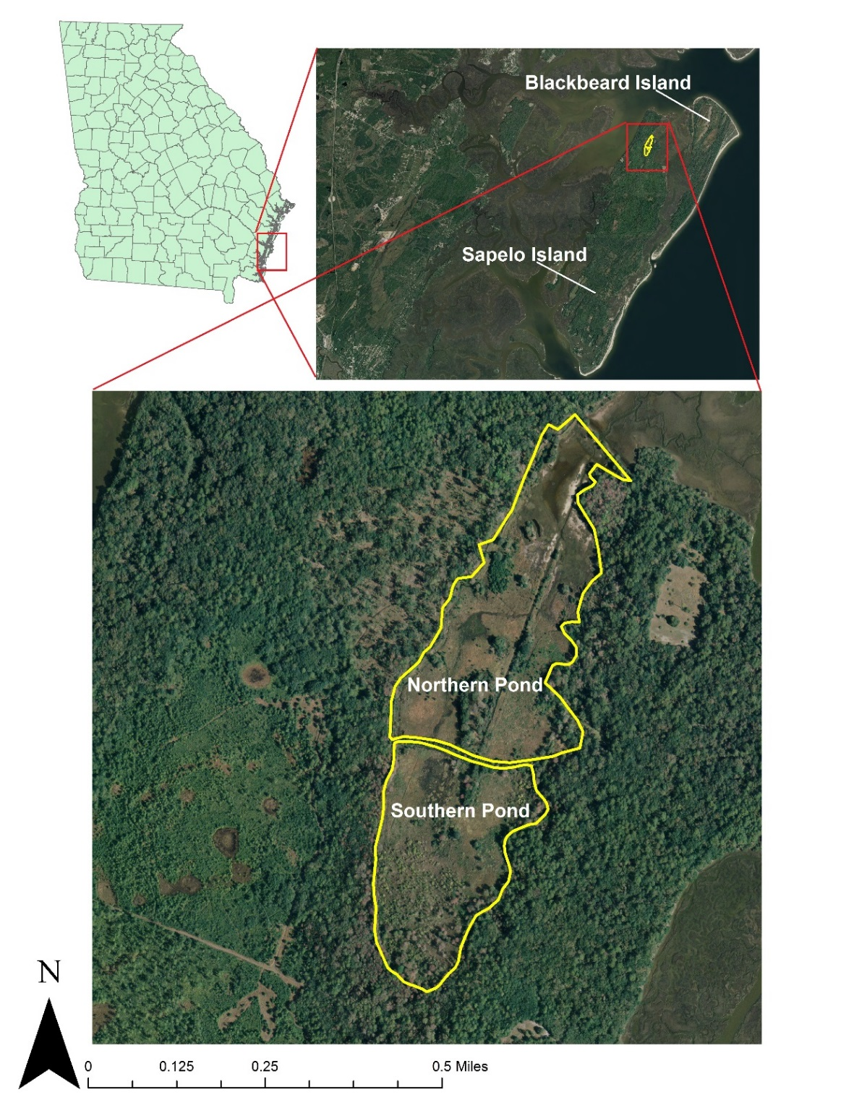
Figure 1. Sapelo Island is a barrier island found off the coast of Georgia (top left). Reynold’s duck pond is located on the northern end of Sapelo (top right). Management plan alternatives were developed for the southern pond (32 acres) due to restrictions on the northern pond (44 acres).
Site Description
Reynold’s duck pond is separated by a dike into a northern and southern pond (Figure 1). The northern pond is influenced by tidal waters resulting in a saltmarsh plant community, while the southern pond may or may not have tidal influence being primarily filled by rain water and freshwater creeks. The southern pond (32 acres) consisted of a mixed covering of herbaceous vegetation, both terrestrial and emergent, floating aquatic plants, and woody species. Wood duck (Aix sponsa), wilson’s snipe (Gallinago delicata), and american coot (Fulica americana) were seen during data collection at the pond in February. Tricolored heron (Egretta tricolor), great blue heron (Ardea herodias), great egret (Ardea alba), and other wading birds have been seen in the pond hammocks by the island manager. White-tailed deer (Odocoileus virginianus), feral hog (Sus scrofa), and feral cow (Bos tarus) were also seen. Feral hog degrade habitat, in this case by rooting up pond vegetation. Rooting evidence as well as hog trails were observed throughout the pond. Twelve wood duck boxes are established along the dike ranging from 4 - 100 meters apart; one box is missing completely, and three others need side panels replaced (Figure2).
Site History
In 1934, R.J. Reynolds Jr. bought Sapelo Island for agricultural purposes and to hopefully make it a self-sustaining investment (Chalmers 2002). The ponds at the north end of the island were artificially made. They were bulldozed out in the late 1920s prior to Reynold’s official purchase. Soon after the original construction, the ponds grew in with cattail plants dotted with open water, much different than how it is now in the year 2015 (Teal and Teal 1964). Currently the island is used for research, managed hunts for white-tailed deer, and for the residential population on the south end of the island.
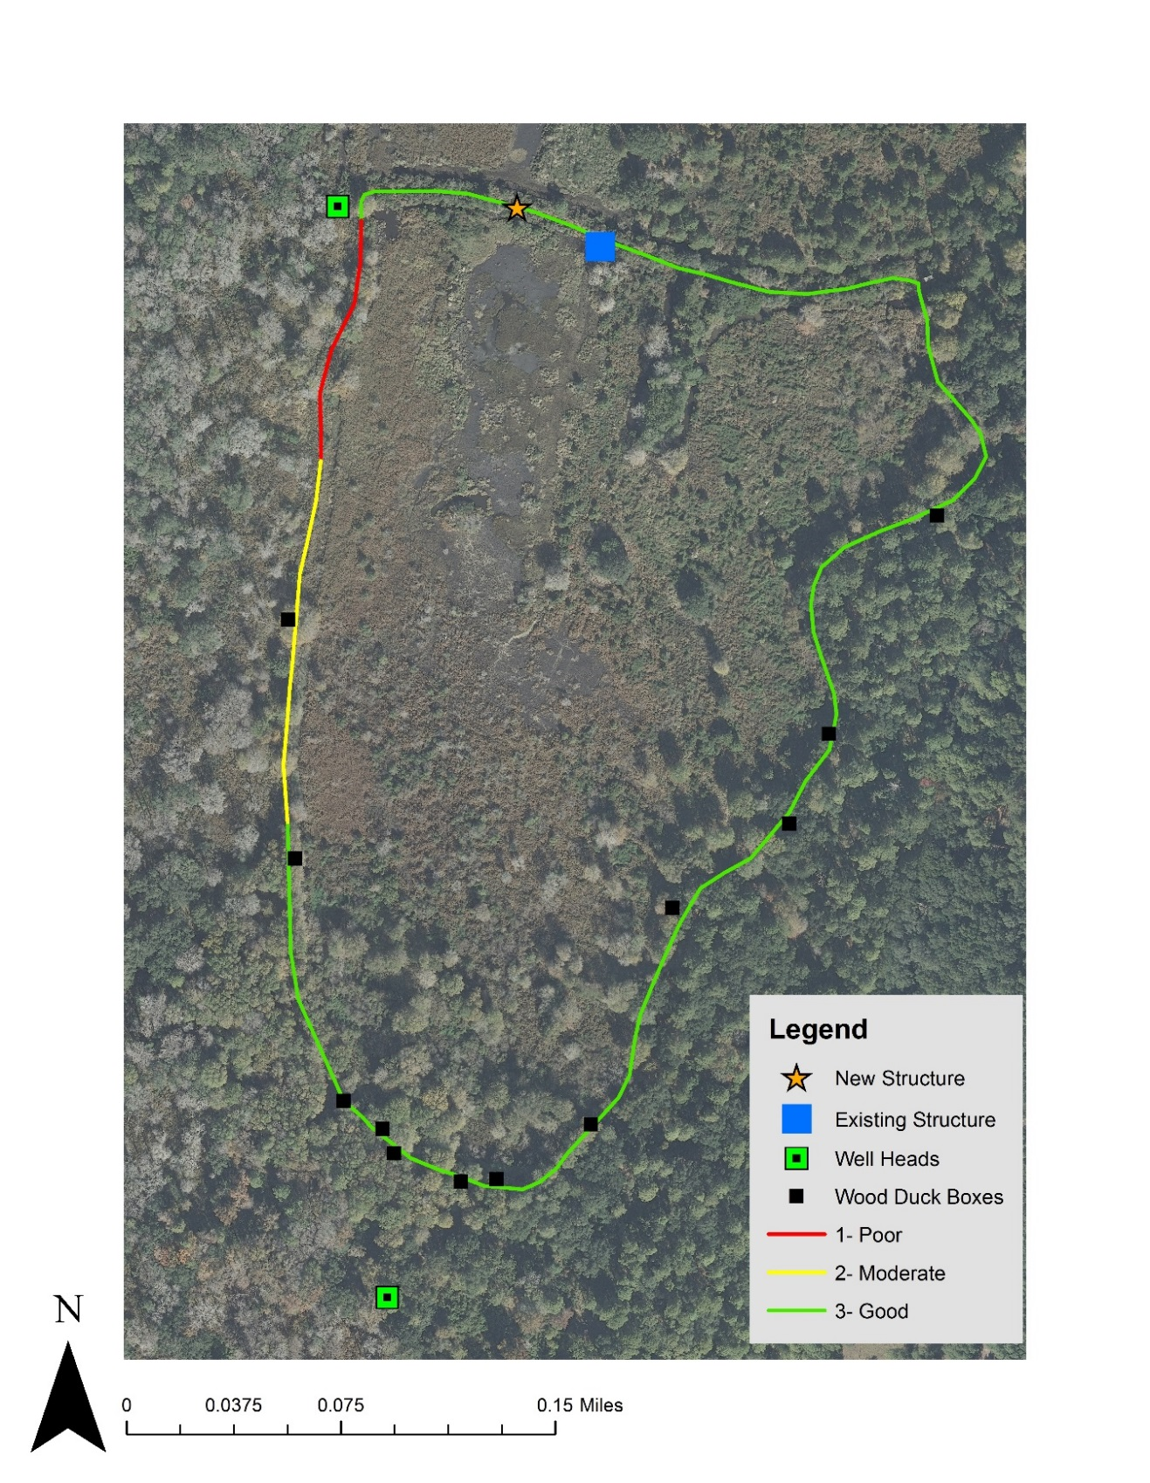
Figure 2. The dike around Reynold’s southern duck pond is used as the perimeter of the pond. Twelve wood duck boxes are located around the perimeter dike. The existing water control structure is in need of replacement; its location is at the north end of the pond as well as the proposed location for a new control structure. Two artesian wells are located outside the pond perimeter. Adequacy of the dike was evaluated on February 28, 2015 based on its height (ft) above standing water, its structural soundness, and ability to retain water. Condition was assessed at points with average interval spacing of 73 meters.
Two artesian well heads were located outside the perimeter of the southern duck pond (Figure 3). The wells formerly flowed with fresh water, but no official records state when they went dry (Chalmers 2002). However, residents of the island reported the artesian wells ceased to flow shortly after Brunswick Cellulose, formally known as Brunswick Pulp and Paper Company, production began on the adjacent mainland in 1938 (R. Morris, personal communication, May 1, 2015).
Reynold’s duck pond was once described as a haven for many bird species during nesting season. Nesting season for herons and egrets begins in April, but within a month the duck ponds would fill with numerous amounts of other birds, too. Anhinga (Anhinga anhinga), gallinule (Gallinula spp.), and many passerine species would soon follow to nests on the islets, which are the small islands within the pond. One islet was documented as holding over one thousand nests (Teal and Teal 1964).
MATERIALS AND METHODS
Sampling Procedures
Dike Condition – The perimeter and area of the southern pond were measured using a Garmin E-trex 20 Global Positioning System (GPS) unit. All the dikes were mowed and brush was cleared back to allow room for equipment. We assessed the perimeter dike’s condition at points that were an average of 73 meters apart. We evaluated the condition of the dike on a relative scale of 1 - 3 (Table 1). There were unstable sections of the dike between the standardized pace points that were noted for having a breach, extremely shallow, or narrow sections. Dike condition was rated based on its ability to retain water, which was in terms of structural soundness, width, and height (ft) above standing water. During dike condition evaluation, wood duck boxes were checked for nest material or egg remains to determine use of the pond for nesting.
Table 1. Perimeter dike conditions of Reynold’s southern duck pond on Sapelo Island, GA were evaluated on March 1, 2015. Justifications for each dike condition rating were based on structural soundness, height (ft) above standing water, and dike width.
Dike Condition | Justification
1 | Poor: Dike needs repairs; shallow (height is < 1 ft) and narrow (< 5 ft wide)
2 | Moderate: Dike stands 1-2 ft above pond water level, > 5 ft wide, but needs to be built to a better condition of ≥ 8 ft
3 | Good: Dike stands ≥ 3 ft above pond water level, and ≥ 8 ft wide, no repair needed

Well Heads and Water Control Structures – Two well heads were located outside the perimeter. The current water control structure is located on the northern dike perimeter of the southern pond (Figure 2). The three structures and their pipes were assessed to determine the possibility of future use by checking the wellhead and pipes for cracks and if water was present within the wellhead.
Vegetation – Samples were taken to determine the southern pond’s plant composition and species were evaluated for salinity tolerance. Vegetation salinity tolerances were used as indicators for the pond’s current salinity levels. Plant species were categorized as facultative halophytes, obligate halophytes, or glycophytes. Facultative halophytes can grow well in salt or freshwater conditions, not requiring salt conditions (Florida Department of Education 1998). Obligate halophytes require salinity to grow and cannot survive in fresh water (Wang et al. 2011). Glycophytes are plant species that prefer freshwater environments (Edwards et al. 2013). We did not separately categorize the glycophyte species in their tolerances to salt conditions.
The southern pond was divided into five sections for vegetation sampling (Figure 3). Each of the five sections had ten sample plots taken periodically along a random azimuth. The randomization was done by rotating a compass until told to stop by the project partner, who could not see the compass. Every sample was taken ten paces (~50 ft) apart from one another; this pace count was determined prior to field sampling. Vegetation samples were taken using a circular sampling plot, which had a diameter of 34.25 inches, resulting in a sample area of 6.4 ft² for each point. Species composition within the plots was recorded by estimating percent area coverage within the sampling plot. Unknown species were collected and later identified at Abraham Baldwin Agricultural College (ABAC).
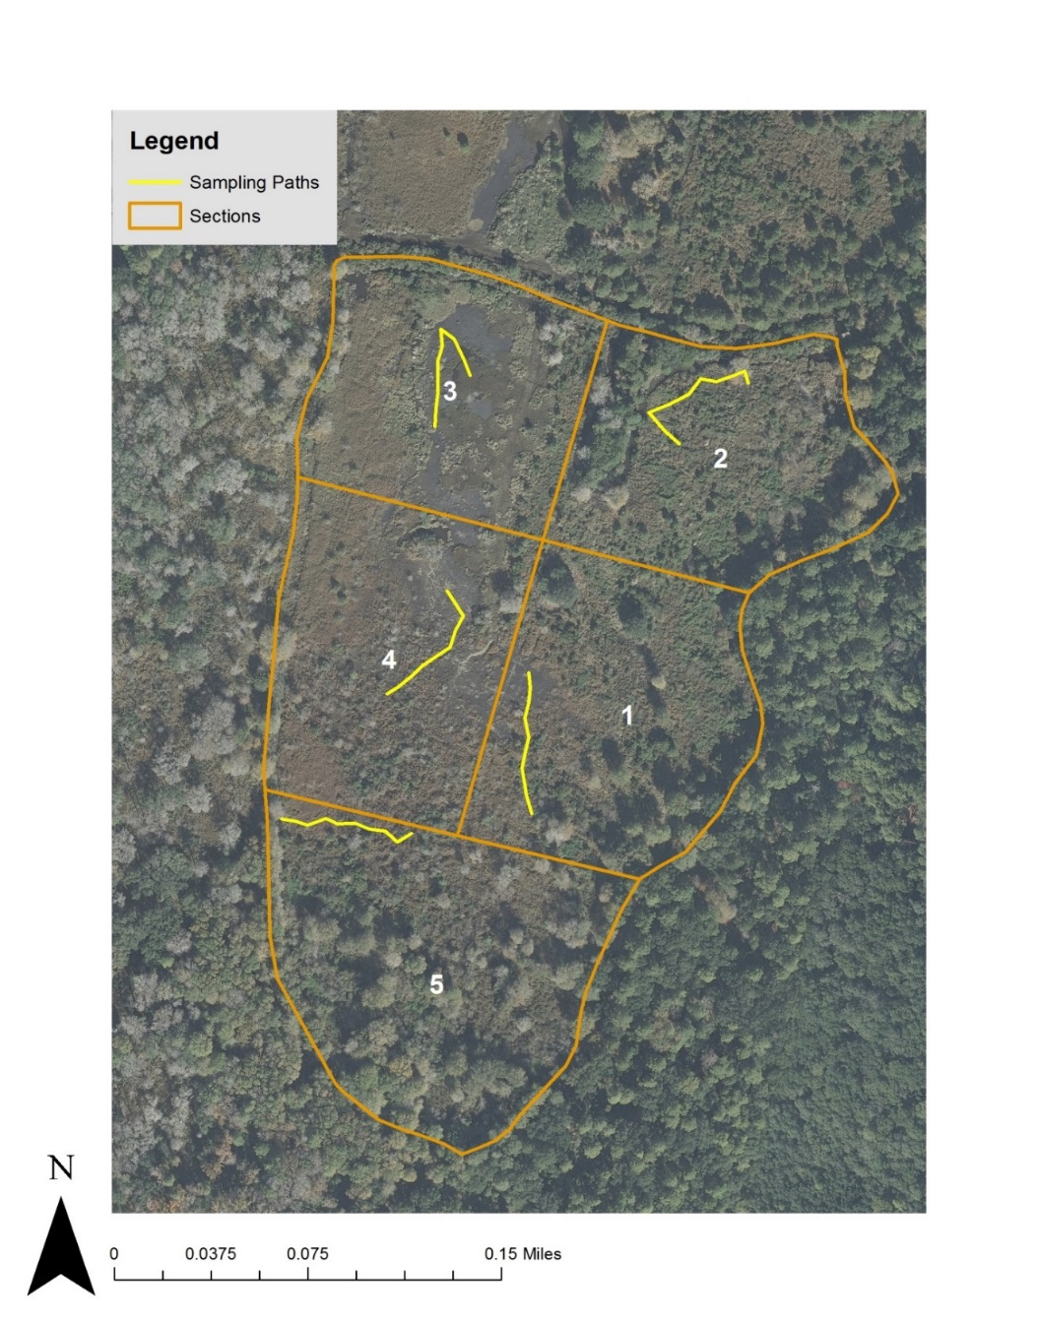
Figure 3. Vegetation sampling paths in 5 sections of Reynold’s 32 acre southern duck pond on Sapelo Island, GA were taken February 28, 2015. Paths were charted along random azimuths, each containing 10 circular sample plots.
Salinity – Five salinity samples were collected along a southern azimuth through the pond by gathering water in plastic bottles at each sample point. Sampling began at the north end of the southern pond where a peninsula extends inward. Salinity samples were taken every 80 meters on average (Figure 4). Two refractometers, which are handheld tools used to measure salinity, were used to evaluate salinity levels in parts per thousand (ppt). To ensure accuracy of results, two refractometers were used to evaluate each sample.
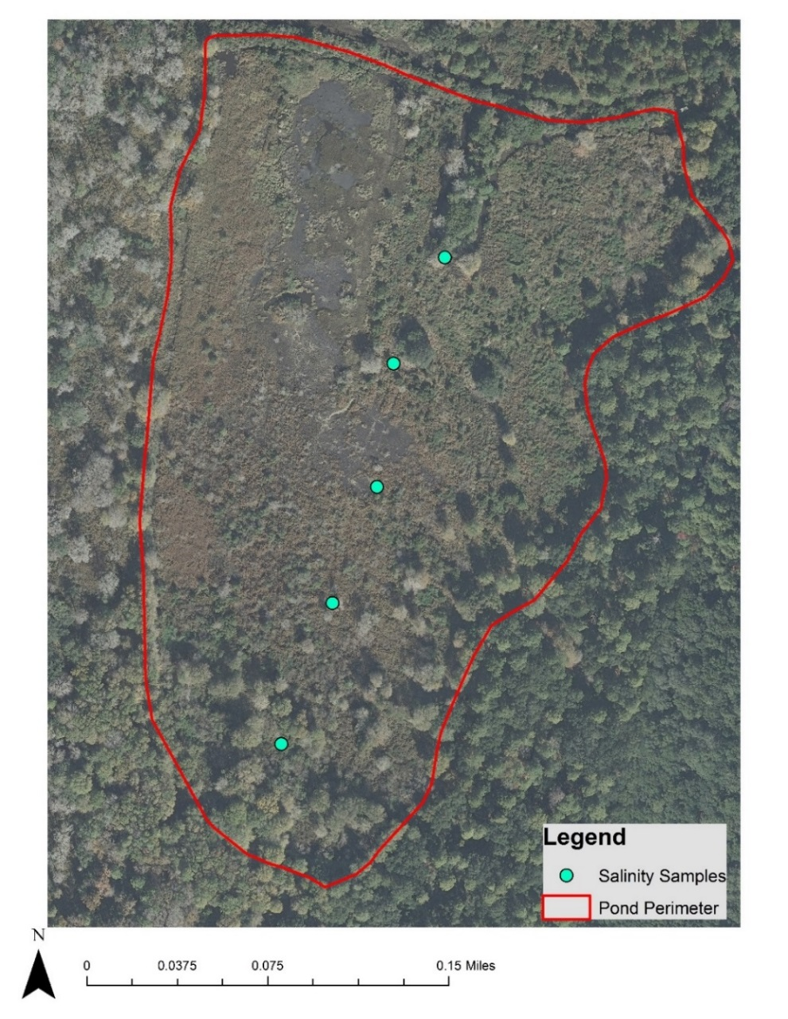
Figure 4. Salinity samples for Reynold’s southern duck pond on Sapelo Island, GA were taken on March 1, 2015 to evaluate the current salinity levels present. Five sample points averaging 80 meters apart were taken along a southern azimuth through the pond.

RESULTS
Reynold’s southern duck pond perimeter is 1607 meters and is lined by a dike that is in various states of condition. Areas along the dike in poor condition, need to be repaired prior to any pond manipulation. Poor zones made up 8.7% (~140m) of the dike. Moderate condition points indicate the dike is stable, but can be built to better condition by increasing its height and width. Moderate zones represented 12.9% (~207m) of the dike. Repairs are not needed on the remaining 78.4% (~1260m) of the dike that is in good condition (Figure 2).
Well Heads and Water Control Structures – Both artesian well heads have no cracks that degrade their ability to retain water, but the pipes are cracked, rusted, and dislodged from the well head frames. (Figure 5). The water control structure had no cracks in the frame, but the pipe was rusted and cracked at both ends.
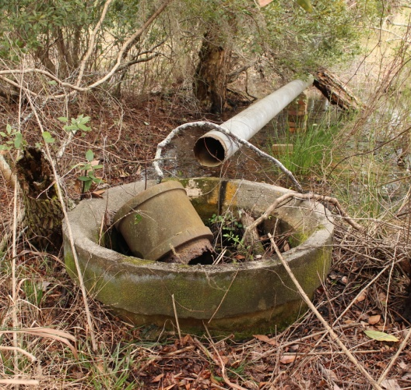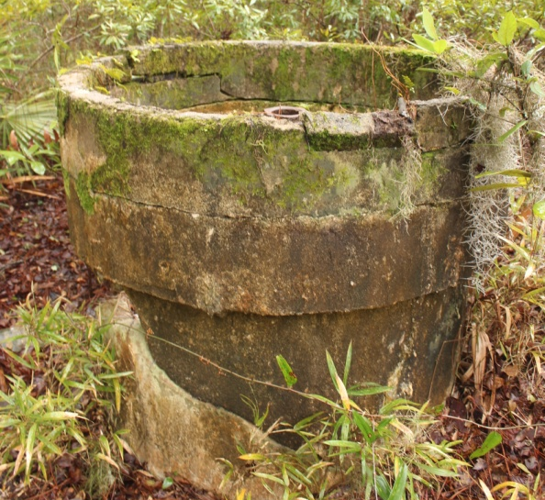
Figure 5. Two artesian well heads are located outside the perimeter of Reynold’s southern duck pond on Sapelo Island, GA. Well head 1 (left) is located on the northwestern corner of the pond and well head 2 (right) is located on the southern end of the pond. Photos were taken February 2015.

Vegetation – The habitat of Reynold’s southern duck pond varied in each section from standing water, islets, blackberry (Rubus spp.) thickets, open marsh, hardwood cover, and bare ground. Twenty-eight different plant species were identified in the pond. We determined percent area coverage of plant species as well as salinity tolerance levels to determine if the pond should be managed for fresh, brackish, or salt water conditions (Table 2). Of the total species sampled from the southern pond, none were classified as obligate halophytes, 68% were facultative halophytes, 8.5% were glycophyte species, and 7.8% were unknown species. Bare ground represented 20.3% of sample plot area.
Salinity – We assessed salinity to determine if the pond should be managed for fresh, brackish, or salt water conditions. Both refractometers showed the same results. All five salinity samples from the southern pond were 0 ppt, indicating fresh water presence at the time of sampling. We also tested salinity on the tap water of the island, which was 0 ppt, and the tidal creek on the west side of the island, which was 18 ppt (Table 3). The tap water and tidal creek samples were evaluated to show functionality of the refractometer’s accuracy to register no salinity and high salinity levels.
DISCUSSION
Dike Conditions – Dike conditions were evaluated to assess the ability to retain water in the pond and identify if it was a limiting factor to the restoration project. Samples allowed sections to be categorized into poor, moderate, and good (Figure 2). Poor condition sections will require heavy equipment for repairing the breeched, narrow and shallow sections to good condition characteristics. Moderate condition sections were not requiring immediate repair, but we recommend restoration to good condition characteristics as well. Good condition sections need no repairs due to overall structural soundness (Table 1). Poor condition sections need careful reconstruction. Heavy equipment use may result in further degradation of the dike if done improperly. Future manipulation of the pond mandates the dike be repaired at both the poor and moderate locations.

Table 2. List of species collected during random during random vegetation sampling on February 28, 2015 within boundary of Reynold’s southern duck pond on Sapelo Island, GA.
Common Name | Scientific Name | Salinity Tolerance* | Percent Present ** | Source
Whorled Marshpennywort | Hydrocotyle spp. | 1 | 12.8 | Tiner 1993
Climbing Hempvine | Mikania scandens | 3 | 1 | unknown
Blackberry | Rubus spp. | 2 | 7.1 | Renalut et al. 1998
Wax Myrtle | Myrica cerifera | 1 | 2.6 | Black 2003
Live Oak | Quercus virginiana | 1 | 0.1 | Black 2003
Common Ragweed | Ambrosia artemisiifolia | 1 | 1.4 | Ditommaso 2004
False Nettle | Boehmeria spp. | 1 | 0.4 | Conner et al. 1986
Panic Grass | Dichanthelium spp. | 2 | 0.6 | Khan et al. 2009
Dwarf Spikerush | Eleocharis parvula | 1 | 2.1 | Tiner Jr. 1984
Black Needle Rush | Juncus roemerianus | 1 | 6.7 | Tiner 1993
Crabgrass | Digitaria spp. | 1 | 0.3 | Chauhan and Johnson 2008
Spanish Moss | Tillandsia usneoides | 1 | 1 | Ital et al. 1968
Red Maple | Acer rubrum | 2 | 1.6 | Tiner Jr. 1984
Loblolly Pine | Pinus taeda | 2 | 0.4 | Tiner Jr. 1984
Rice Cutgrass | Leersia oryzoides | 1 | 8.5 | Tiner Jr. 1984
Switchcane | Arundinaria gigantea | 1 | 5.5 | Tiner Jr. 1984
Vasey Grass | Paspalum urvillei | 1 | 1 | Eleuterius and McDaniel 1978
Eastern Baccharis | Baccharis halimifolia | 1 | 0.2 | Tiner 1993
Flatsedge | Cyperus spp. | 1 | 3.2 | Quinn and Feldmann 2004
Water Primrose | Ludwigia spp. | 1 | 0.4 | Archana and Kumar 2014
Smartweed | Polygonum spp. | 1 | 1.2 | Tiner Jr. 1984
Spikerush | Eleocharis spp. | 1 | 6.3 | Tiner Jr. 1984
Duckweed | Lemna spp. | 1 | 1.6 | Tiner 1993
Dog Fennel | Eupatorium capillifolium | 1 | 0.2 | Stieglitz and Wilson 1968
Unknown species (3) | - | 4 | 7.8 | -
*1: facultative halophytye, 2: glycophyte, 3: unknown salt tolerance, and 4: unknown species
**Average species composition within the total vegetation sample area

Table 3. On March 1, 2015 salinity samples were taken every 80m following a southern azimuth starting at the northern edge of Reynold's southern duck pond, on Sapelo Island, GA, and were tested with two refractometers, both showing the same results. Tap water was used as the control, and a tidal creek on the island's edge was used to test a maximum.
Point | Refractometer Reading (ppt)
1 | 0
2 | 0
3 | 0
4 | 0
5 | 0
Tap water | 0
Tidal creek | 18

Well Heads and Water Control Structures – It may be possible to pump water from the artesian wells with a Power Take-off (PTO) driven pump operated by a tractor. The pipes do not need to be replaced for the well heads to become useable water sources. They could be manually pumped to flood the pond in drought years (Figure 6). The water control structure needs complete replacement. We suggest leaving the existing structure for its historic value, and installing a new structure elsewhere if desired.
Vegetation –Certain species such as smartweed, common ragweed, duckweed, and rice cutgrass are valuable to waterfowl (Baldassare 2006). These four species meet waterfowl dietary needs and represent 12.7% of our samples. Future management of the pond will promote valuable species and reduce invaluable, invasive species such as climbing hempvine and dog fennel which represent 1.2% of our samples. Monocultures of any species should be avoided to promote healthy pond diversity.
To evaluate the salinity influence of the pond, species present and their tolerance levels were determined. Vegetation sampling was useful as a salinity indicator of Reynold’s southern duck pond. Plant species have different environmental requirements, which are helpful in evaluating habitat conditions of the landscape, such as salinity. Section 2 of our vegetation plots borders the dike closest to the northern pond, containing blackberry, red maple, and loblolly pine, which are classified as glycophyte species. None of the species present in our sample plots were obligate halophytes. This would seem to indicate that the southern pond is freshwater. However, we recommend extending the vegetation samples throughout the pond to verify salinity intolerant and tolerant species. Our vegetation samples were inconclusive for the salt condition determination.
Salinity – Refractometers were used to directly evaluate water salinity levels in the pond. Evaluation of salinity levels was necessary to determine what type of ecosystem is present within the pond. Research has shown barrier islands have their own aquifers that rely solely on rain to replenish them. As the aquifers expand, the fresh water within them moves subsurface towards the island’s outer perimeter, any salt water contamination of the aquifer, is then pushed out. Considering this process is dependent on rain water, it is believed that in years with regular rain events, the pond would be freshwater. Possibility of salt water intrusion may occur in drought years due to lack of aquifer pressure and extreme tidal influence through the northern pond. We feel this is unlikely to occur in the southern pond due to the distance from the salt water, as well as the retained fresh water in the pond (Edwards et al. 2013). Our samples were taken after a heavy rain. To insure the pond is freshwater, we recommend more salinity samples should be taken.
As the southern duck pond was evaluated, short comings were inevitable. Clearing the southern duck pond dikes of brush and logs had to be done prior to data collection. We were limited on time and this delayed evaluation of the pond by a day. The lower section of the pond, section 5, was larger than the other four sections used during the vegetation sample (Figure 3). When randomizing our points of sample, we underestimated the area of the pond. After samples were taken, we noticed a larger amount of woody vegetation in section 5 that should be noted in the future. The entirety of section five’s size was not visible on the original map due to tree coverage over dike boundaries on aerial photos. Distances between sample points were not consistent. Inconsistency resulted from blackberry thickets, limbs, logs, muck, tripping over air, and other limiting factors when sampling vegetation. Vegetation sampling was only taken on 0.0005 % of the southern pond. We noted that broomsedge (Andropogon virginicus) was present, as well as larger woody species in the southern section of the pond. Taking samples in late winter made us unsure what species are present in the spring after growth has occurred, and made some plant species unidentifiable. Due to time constraints, salinity tests were taken only on a single transect through the center of the pond. This creates a gap in our data collection on the east and west divisions within the pond. If future water salinity sampling is performed, data should be gathered from all sections of the pond for further verification. Artesian wells need to have water samples conducted to insure they are freshwater sources. We also recommend taking soil samples throughout the southern pond. Saltwater is more dense than fresh water, and it is possible that saltwater exists below the surface of the pond (Edwards et al. 2013).
Management Plan Descriptions
Each of the following alternatives for management of Reynold’s southern duck pond were developed by surveying various aspects of the pond including: dike condition, the pond’s existing water control structures, vegetation, and water salinity levels. Each management plan has different costs, labor intensities, and time frames.
There are various costs that come with each management plan to create optimal habitat in the southern duck pond. Osceola Machine Company was contacted for flash board riser system prices. Lumber companies were contacted for marine treated pine board estimates as a material supplier to build a rice trunk control structure. Hancock Seed Company has several wildlife seed blends, one of which is valuable to waterfowl impoundment management. Mercantile companies were contacted for estimates on hoses, pumps, and other equipment (Table 4).
Table 4. Materials, prices, and sources for each management plan option for Reynold’s southern duck pond on Sapelo Island, GA.
Management Plan 1
Materials | Price | Source
N/A | N/A | N/A
Total | $ -
Management Plan 2
Material | Price | Source
Flash Board Riser | $ 514.99 | Osceola Machine; Osceola, AR  www.osceolamachine.net
Riser Pipe | $ 299.99 | Menard’s; Eau Claire, WI  www.menards.com
Anti Seep Collar | $ 226.86 | Drainage Solutions; Franklin, IN  www.drainagesolutionsinc.com
Total | $ 1,041.84
Management Plan 3
Material | Price | Source
Flash Board Riser | $ 514.99 | Osceola Machine; Osceola, AR  www.osceolamachine.net
Riser Pipe | $ 299.99 | Menard’s; Eau Claire, WI  www.menards.com
Anti-seep Collar | $ 226.86 | Drainage Solutions; Franklin, IN  www.drainagesolutionsinc.com
Pump | $ 6,269.99 | Water Pumps Direct; Bolingbrook, IL  www.waterpumpsdirect.com
Hose | $ 449.99 | Water Pumps Direct; Bolingbrook, IL  www.waterpumpsdirect.com
Seed | $ 1,249.75 | Hancock Seed Company; Dade City, FL  www.hancockseed.com
Total | $ 9,011.57

Management Plan 1
We wanted to construct a plan that involved no cost, as well as no maintenance, for a low intensity option. This involves leaving Reynold’s southern duck pond in its current state. The southern pond is currently being utilized by wood ducks, wading birds, and shorebird species. The vegetation in the pond offers food and breeding habitat for a variety of species. While only some of the vegetation found is beneficial, there is no need for additional planting or maintenance since quality species are already present. Of the 27 species collected during vegetation sampling, 11 are valuable for nutrition and providing nesting habitat. The species valued for nutrition include the following: whorled marshpennywort, common ragweed, fall panic grass, dwarf spikerush, crabgrass, rice cutgrass, water primrose, smartweed, spikerush, and duckweed. The species used for habitat is vasey grass. These 11 species make up 36.2% of the sample data, indicating suitable vegetation is present in the pond at its current state.
We recommend repairing the poor and moderate sections of the dike. Heavy machinery, such as a long arm track hoe, will need to be brought in from the mainland along with any labor requirements. The cost of equipment usage and labor involved with dike repair is not factored into this management plan. Labor wage is variable among positions, and fuel costs change on a daily basis. Georgia DNR already has allotment in their monthly budget for movement of equipment across the state and for fuel cost. The wages of laborers involved would be part of their normal paycheck. Taking all of this into account, it is not necessary to add those costs to this plan as it will still be a no cost alternative even with dike repairs. With no prerequisite to repair water control structures, the pond would be filled by rainwater alone. Drought years may lessen the number of species that utilize the pond as a stopover sight as well as breeding grounds due to lack of standing water. Considering the goal of providing improved habitat for waterfowl and shorebirds, drought years would be detrimental.
A benefit to this plan is low cost of implementation, it exploits what advantages are already found within and around the pond. The wood duck boxes around the pond are not in over-abundance and had evidence of use (Figure 2). The USDA Natural Resource Conservation Service (2003) recommends ten acres minimum of proper habitat, which the southern pond and surrounding area has. The number of boxes suggested for any given site varies. Semel et al. (1988) recommends that the number of boxes should be in densities that replicate what could occur naturally. No assessment of the number of cavities that could occur naturally on Reynold’s southern duck pond was done. We recommend evaluating natural cavity presence before additional boxes are established. This plan is viable for implementation, being that Reynold’s southern duck pond has already been self-sustaining and may provide habitat for waterfowl and shorebirds without any maintenance. The response by target avian species would be short of 1960’s descriptions (Teal and Teal 1964). If low cost is an important factor, this plan could be utilized without any recognizable consequences.
Management Plan 2
This alternative will create a semi-permanent wetland using a water control structure, creating rookery habitat for shorebirds in the southern pond’s islets. The techniques used for this alternative would be as follows: 1) install flashboard riser, 2) drain pond, 3) implement prescribed fire, and 4) flood pond. The first step is to remove the existing pipe used by the existing flash board riser and install a new flash board riser about 50 meters from the existing control structure (Figure 5). Heavy equipment, such as a track hoe, as well as laborers would be needed to install this new water control structure. By installing a new flash board riser system, pond levels would be significantly easier to manipulate and achieve management goals. During this process, we recommend poor and moderate sections of the dike be repaired following the rationale described in the first management plan. Following installation of the new flash board riser system, completely drain the pond, allowing a drying period. Drying periods should be a minimum of two weeks to avoid a monoculture and allow stabilization of soils (Smith et al. 1989).
Once appropriate conditions are met, a prescribed burn should be applied across the entire pond to remove undesirable vegetation, such as climbing hempvine, an invasive species, and prevent a monoculture of any species. Allowing the pond to dry before burning will allow undesired vegetation to dry out and promote a complete burn. Construction of a semi-permanent wetland will also turn some of the larger trees into snags allowing woodpeckers, songbirds, and waterfowl to use cavities for nesting. Once the pond has been burned, the riser boards will be installed into the flash board riser box retaining water in the pond. This alternative relies solely on precipitation throughout the year for flooding. Drought years will reduce water levels as well as the vegetative component that can survive in the southern pond.
Every four to five years, the pond will be drained, disked, and burned to continue promoting vegetative diversity. Limited rookery habitat is found along the Georgia coast, and managing for it on Sapelo Island would be beneficial for wading birds. Rookeries, which are colonies of birds, nest in clumps of trees on the islets and around the southern pond’s edge. When flooding is complete, some trees will die creating snags for cavity nesters, such as nuthatches (Sitta spp.), hooded mergansers (Lophodytes cucullatus), black-bellied whistling ducks (Dendrocygna autumnalis), and wood ducks. Prescribed fire would reduce undesired species such as blackberry and climbing hempvine and promote desired species, such as smartweed, ragweed, and rice cutgrass. We prefer prescribed fire over herbicide to reduce and promote vegetation for nutrient replenishment, control, and lower costs. The promotion of these species is not only for nutrition, but also as cover habitat for species that nest in vegetation and over water. Species such as whorled marshpennywort are not used for direct consumption by wading birds and waterfowl, but they provide habitat for invertebrates, which can be consumed by resident populations for protein.
For Reynold’s southern duck pond, a flash board riser is believed to be the best option for re-establishing a better rookery habitat. A flash board riser involves installing the riser boards when you want the pond to fill. The level of the riser boards is where the water level in the pond will remain. By removing the boards, the pond will drain, stopping at the desired water level. For rookery habitat management, boards would be removed once every four to five years for pond maintenance or prescribed fire to prevent a monoculture of any one species. After reinstallation of the riser boards, the pond will fill as it gathers rainfall.
Management Plan 3
This alternative recommends developing Reynold’s southern duck pond into a moist soil management area. Poor and moderate sections of the dike are recommended for repair in order to accomplish pond manipulations, such as flooding. While heavy equipment used for dike repair is on location, installation of a flash board riser system is recommended. Upon installation of the flash board riser box, the following steps should be taken: 1) pond drainage, 2) prescribed fire, 3) ground cultivation, 4) plant seed mix, and 5) gradually flood. Trees within the pond interior should be cut and removed prior to tilling. While tilling will remove the existing species, the recommended seed will provide a valuable composition of plants. The time of year to disk and plant wetland plants varies on what species of waterfowl you want to use the pond, as well as how much production you want from the vegetation (Baldassarre 2014). Draining the pond and planting in May will result in a higher yield of vegetation, but reduce brood habitat for wood ducks; planting in July decreases the yield of plants, but promotes better wood duck brood habitat. Our recommendation is to plant in June, extending brood habitat presence and yielding an adequate amount of vegetation for the wintering population. Quality habitat is created by planting wetland species. A waterfowl impoundment along the ducks migration route for increasing their fat reserves is necessary for their survival (Baldassarre 2006). Selecting vegetation species that are high in carbohydrates, such as rice, is recommended to increase their energy reserve. In Georgia, waterfowl do not need a high intake of proteins during their fall migration, making carbohydrate rich vegetation valuable (Smith et al. 1989). The riser boards should be put in place before waterfowl season. If no rain is forecasted between the installation of the boards and waterfowl season, the existing artesian wells will have to have water pumped from them to flood the pond to the desired level. Flooding the pond shortly before waterfowl season will attract ducks early and with quality vegetation present, increased amounts of waterfowl will stay throughout the entire season. This promotes better hunts, happy hunters, and positive public relations.
The negative aspects of this alternative are it is an expensive and labor intensive option (Table 4). Funding would also be needed for the seed and pump. Fuel would be required for the tractors and for the pump when the wells are utilized. This alternative is expensive, but will yield quality habitat for waterfowl, wading birds, and shorebirds. The amount of waterfowl species that will use this type of wetland is greater than either of the previous management alternatives.
Implementation of a moist soil management area would be a valuable resource to waterfowl. The amount of nutritional value gained within the southern duck pond would be worth the cost and effort involved. After completion of planting, the plants should be monitored for successful growth and production until migration begins. Two weeks before migration begins, riser boards will need to be installed and the pond will need to be flooded. If not enough rain is predicted for that two week period, the artesian wells should be employed. While this involves additional labor, being able to manually flood the pond whenever necessary, will eliminate risk of the pond not flooding. If there is no water in the pond before birds begin arriving, use may not occur and the planting of seed will have been wasted. Installation of the riser boards and flooding of the pond will need to be done on time. After waterfowl migration is over and only the resident birds remain, the pond will need to be drained leaving at least 10% of the pond flooded to incorporate habitat conditions for wading birds and shorebirds. At the end of May, after wading birds and shorebirds have fledged, finish draining the pond and allow time to dry before cultivation begins for the next season (Strader and Stinson 2005). .
By providing an ecosystem that is not commonly found along Georgia’s coastline, the goals of providing quality habitat for waterfowl, wading birds, and shorebirds would be achieved. Having standing water in the pond under wading bird nests would give an extra guard against predators, as well as present foraging grounds (Strader and Stinson 2005). We believe by providing this type of ecosystem, waterfowl will be drawn to the southern duck pond in greater numbers than what currently uses the pond, and wading birds and shorebirds will be restored to historic numbers.
CONCLUSION
We recommend management plan 2 for Reynold’s southern duck pond. This plan would provide GADNR with the best results based on their objectives while keeping costs low. A flash board riser is considered to be the most viable water control structure for this plan due to their simplicity and ease of use. Following installation, they only require adjustment of the riser boards to manipulate the water levels within the pond. Management plan 2 only requires manipulation of the riser boards every 4 – 5 years, making maintenance efforts relatively low as well. Maintenance will only be needed in the years where draining, disking, and burning are applied. As discussed earlier, the labor and fuel costs are not relative to the overall cost of plan 2. These are accounted for in the monthly budget regardless of what work is being completed. Taking into account the lack of rookery habitat along the Georgia coastline, managers could provide many bird species with a unique environment. Landowner goals of providing suitable habitat for species of waterfowl, shorebirds, and wading birds can be attained along with possibly providing new habitat for woodpecker species (Picidae spp.) with the creation of snags. With this type of management more than birds alone will gain habitat. Mammals can use it as a new source of drinking water or as habitat in general, when referring to semi-aquatic species. These species could include river otter (Lontra canadensis), american beaver (Castor canadensis), or american mink (Neovison vison). In addition, various types of amphibians and reptiles, such as bullfrog (Lithobates catesbianus) or southern banded water snake (Nerodia fasciata) may use the pond. We also believe that leaving the pond in its current state, implementing management plan 1, wastes the potential value of Reynold’s southern duck pond. Historic evidence shows use of the duck pond was considerably higher than what is currently seen. By managing the southern pond, we hope to restore the habitat and increase waterfowl, wading bird, and shorebird use back to historic documentations. We considered management plan 2 to be an equal compromise of both plans, conducting maintenance every 4 – 5 years to restore the pond. Management plan 2 provides better habitat than plan 1, while keeping costs lower than plan 3.
ACKNOWLEDGEMENTS
We would like to extend a special thank you to all of those involved. This project would not have been possible without the help of both GADNR as well as other volunteers. We thank Mr. Fred Hay, the GADNR island manager of Sapelo Island, for allowing us to stay on the island and use their equipment to conduct research for the project. We also thank Robert Horan, the GADNR Tech 4 of the game management section in Region 7, for his guidance and encouragement to carry out the project. We would like to also thank Dr. Jason Scott and Daniel Sollenberger, our ABAC professors and project advisors, who gave us continual direction to complete this project. We would like to thank Mrs. Aimee Gaddis, who allowed us to use her GIS data of Sapelo Island and sent us the historical picture of Reynold’s pond used in our presentation. We extend our sincere thanks to Stanley Walker, a GADNR employee for Sapelo, Blaine Tyler, a GADNR non-game employee, Mark Day, GADNR law enforcement on Sapelo Island, and Kaylee Pollander, a UGA Grad Student, who all volunteered to help make research avenues possible for the project.

LITERATURE CITED
Archana, P. and A. Kumar. 2014. Bioremediation of Saline Soils Using Aquatic plants. Unique Journal of Pharmaceutical and Biological Sciences 2:63-67.
Baldassarre, G. 2014. Ducks, Geese, and Swans of North America. Johns Hopkins University Press, Baltimore, Maryland, USA.
Baldassarre, G.A., and E.G. Bolen. 2006. Waterfowl Ecology and Management. Second Edition. Kreiger Publishing Company, Malabar, Florida, USA.
Black, R.J. 2003. Salt-Tolerant Plants of Florida. University of Florida’s Institution of Food and Agricultural Sciences Extension.
Chalmers, A. G. 2002. The Ecology of the Sapelo Island National Estuarine Research Reserve. University of Georgia Marine Institute. < http://www.sapelonerr.org/wp-ontent/uploads/2013/ 08/Ecology-of-the-Sapelo-Island-National-Estuarine-Research-Reserve.pdf>. Accessed 30 Mar 2015.
Chauhan, B.S. and D.E. Johnson. 2008. Germination Ecology of Southern Crabgrass and India Crabgrass; to important weeds of Rice in Tropics.
Conner, W.H., Sasser, C.E., and Barker N. 1986. Floristics of the Barataria Basin Wetlands, Louisiana. Castanea 5:111-128.
Ditommaso, A. 2004. Germination behavior of common ragweed (Ambrosia artemisiifolia) populations across a range of salinities. Department of Crop and Soil Sciences. Weed Sciences 52:1002-1009.
Edwards, L., J. Ambrose., and L.K. Kirkman. 2013. The Natural Communities of Georgia. University of Georgia Press, Athens, Georgia, USA.
Eleuterius, L. N. and S. McDaniel. 1978. The Salt Marsh Flora of Mississippi. Appalachian Botanical Society. Castanea 43:85- 95
Florida Department of Education. 1998. Morphological and Physiological Adaptations. <http://www.nhmi.org/mangroves/phy.htm>. Accessed 4 May 2015.
Ital, C., A. Richmond, and Y.Vaadia. 1968. The role of root cytokines during water and salinity stress. Israel Journal of Botany. 17:187-195.
Khan, Z.H, I. Qadir, S. Yaqoob, R.A. Khan, and M. A Khan. 2009. Response of Range Grasses to Salinity Levels at Germination and Seedling Stage. Journal of Agricultural Research 47:179.
Quinn, N. and S.A. Feldmann. 2004. Wetland Plant Guide for Assessing Habitat Impacts of Real-Time Salinity Management. University of California Berkeley Laboratory.
Renault, S. and C. Lait, J.J. Zwiazek, and M. MacKinnon. 1998. Effect of High Salinity Tailing Waters Produced from Gypsum Treatment of Oil Sands Tailings, Plants of the Boreal Forest. Environmental Pollution 102:177-184.
Semel, B., P. W. Sherman, and S. M. Byers. 1988. Effects of brood parasitism and nest-box placement on Wood Ducks breeding ecology. Condor 90:920-930.
Smith, L.M., R.L. Pederson., and R.M. Kaminski. 1989. Habitat Management for Migrating and Wintering Waterfowl in North America. Texas Tech University Press, Lubbock, Texas, USA.
Stieglitz, W.O. and C. T. Wilson. 1968. Breeding Biology of the Florida Duck. Journal of Wildlife Management 32:921-934.
Strader, R.W., and P.H. Stinson. 2005. Moist-Soil Management Guidelines for the U.S. Fish and Wildlife Service. Migratory Bird Field Office, Division of Migratory Birds. Jackson, MS. <http://www.fws.gov/columbiawildlife/MoistSoilReport.pdf>. Accessed 1 May 2015.
Teal, J., and M. Teal. 1964. Portrait of an Island. University of Georgia Press, Athens, Georgia, USA.
Tiner, Jr., R. W. 1984. Wetlands of the United States Current Status and Recent Trends. U.S. Fish and Wildlife Service. US Department of Interior’s Fish and Wildlife Services. Habitat Resources, Washington, D.C., USA.
Tiner, R.W. 1993. Field Guide to Coastal Wetland Plants of the Southeastern United States. Thomaston-shore, Sabon.
U.S.A Corps of Engineers. Definition of Navigable Waters of the US. <http://www.nap.usace.army.mil/Portals/39/docs/regulatory/regs/33cfr329.pdf>
U.S. Department Agricultural’s Natural resource Conservation Service. 2003. Wood Duck (Aix sponsa). Wildlife Habitat Council. Biology Technical Note Number MT-3. Pg 12.
Wang, W., Z. Yan, S. You, Y. Zhang, L. Chen, and G. Lin. 2011. Mangroves: Obligate or Facultative Halophytes? A Review. Trees 25:953-963.

APPENDICIES
Appendix A. Material Costs


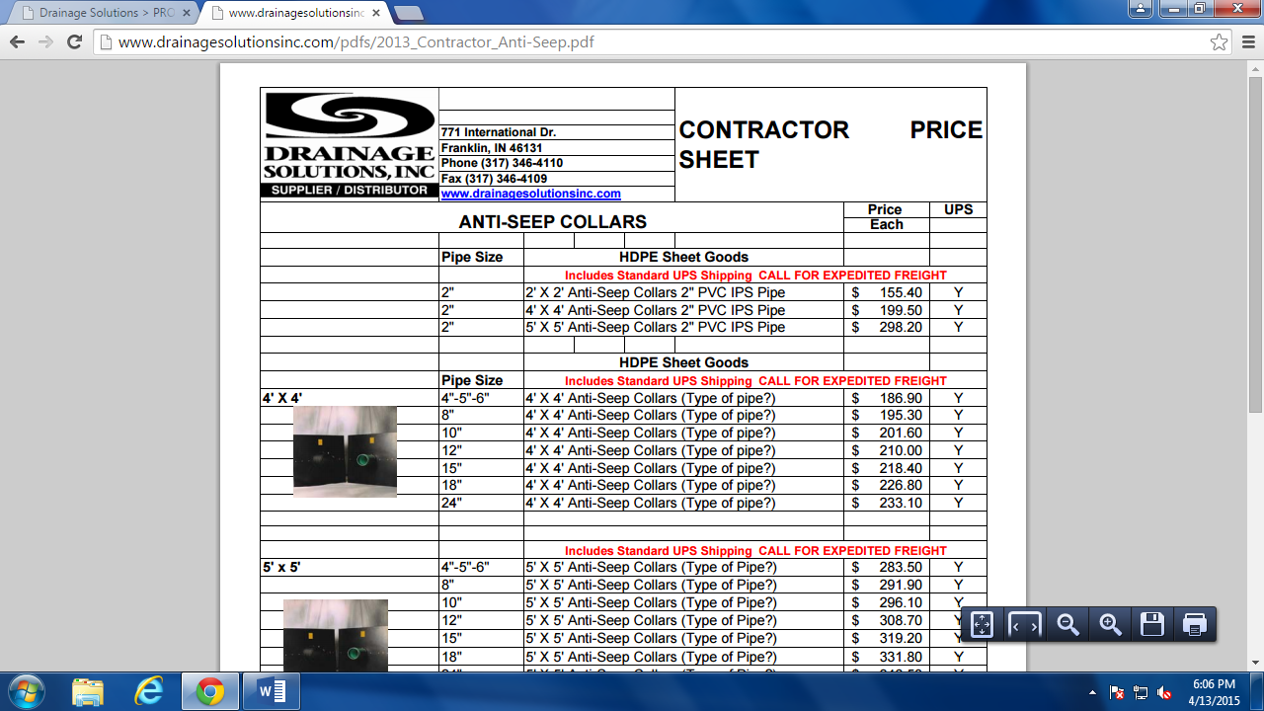

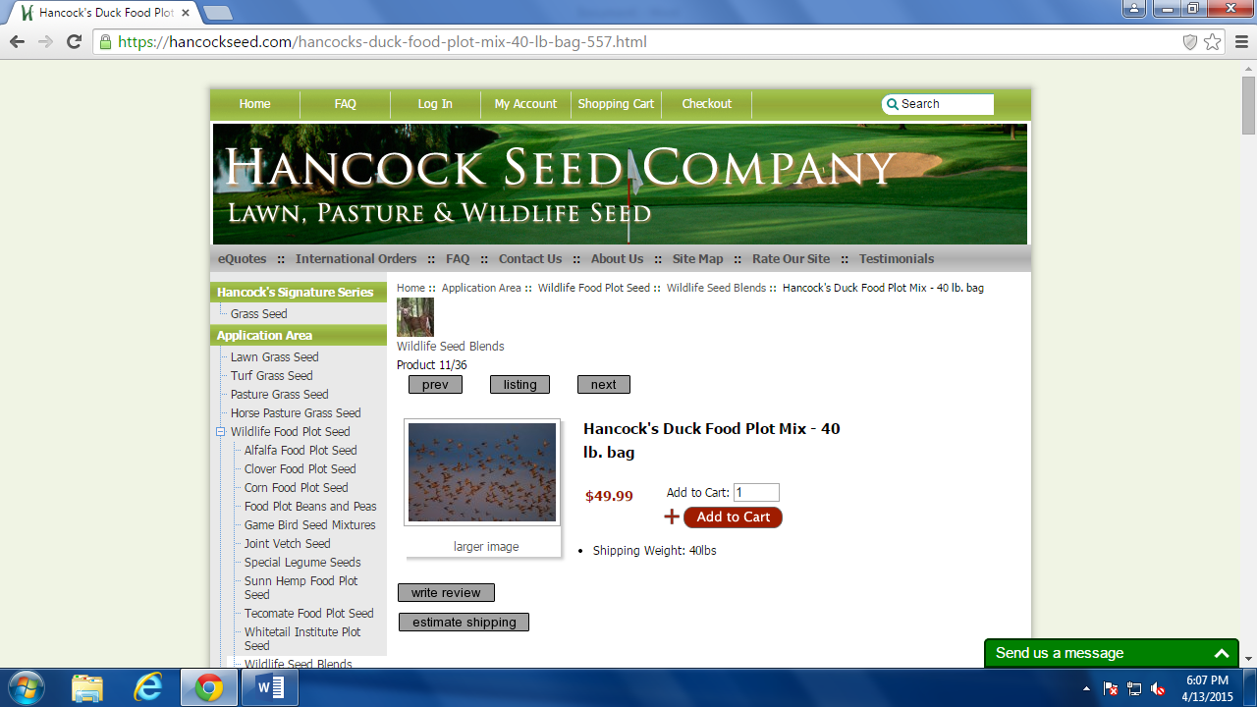

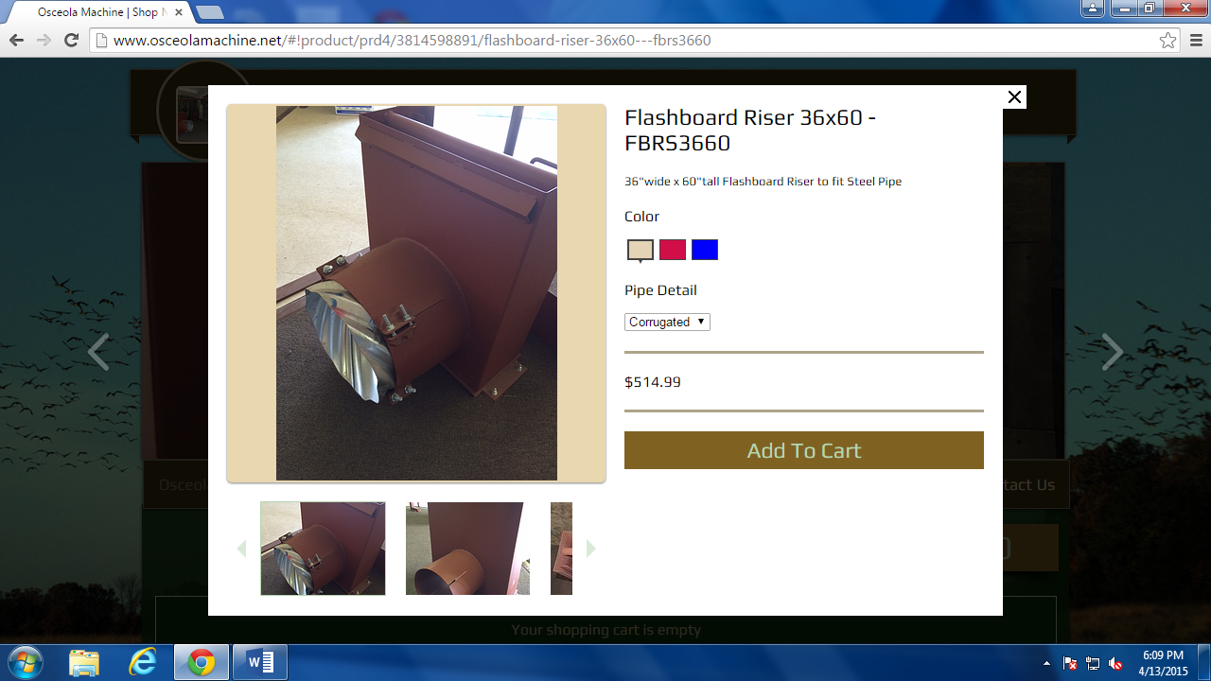

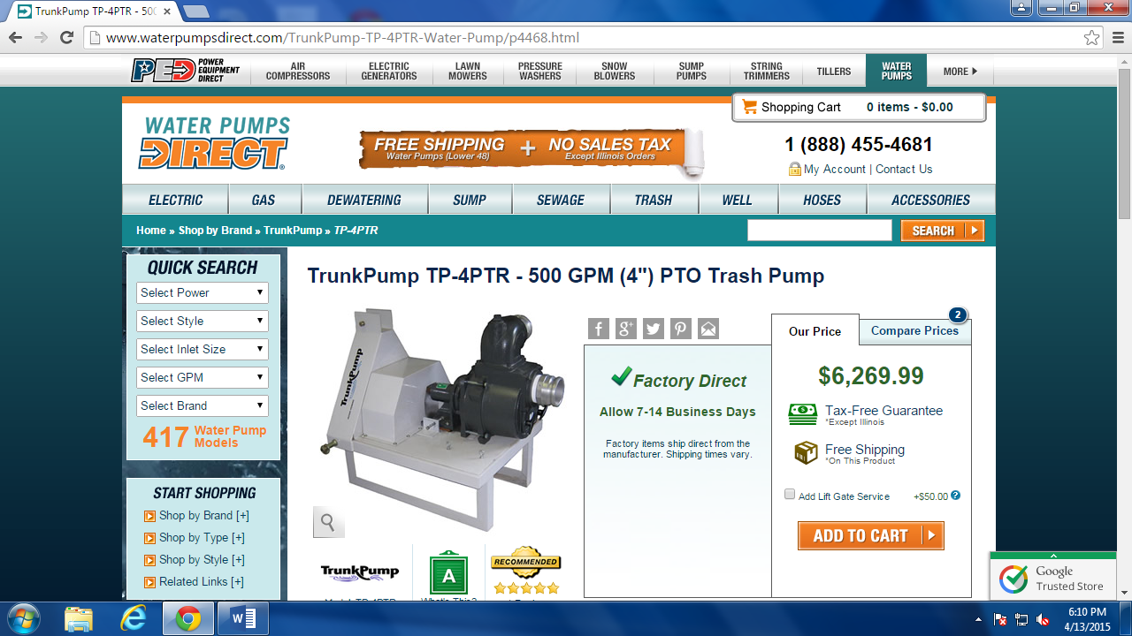

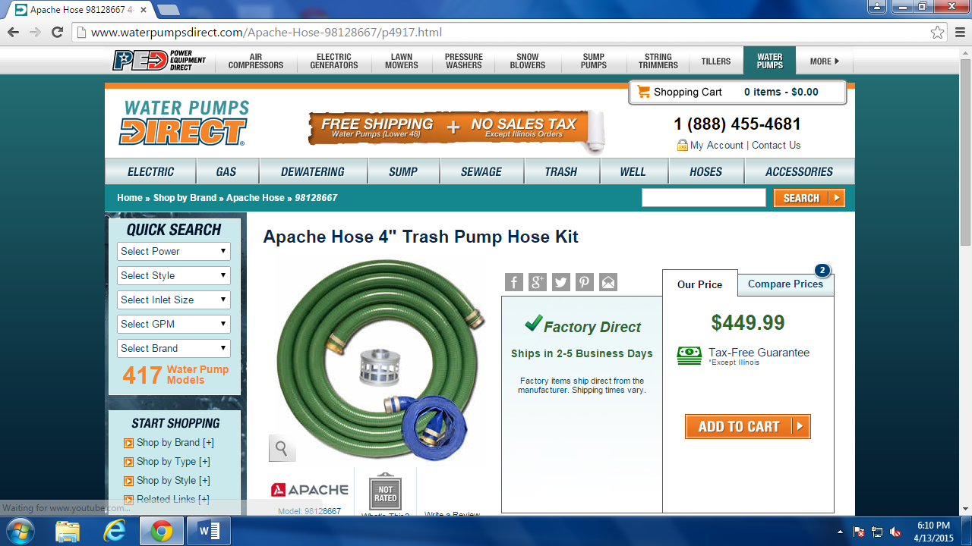

Appendix B. Other Project Pictures

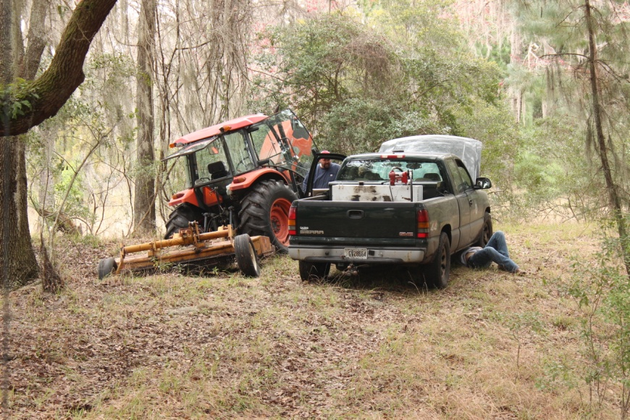
A little mechanical work before the day began February 28th, 2015.

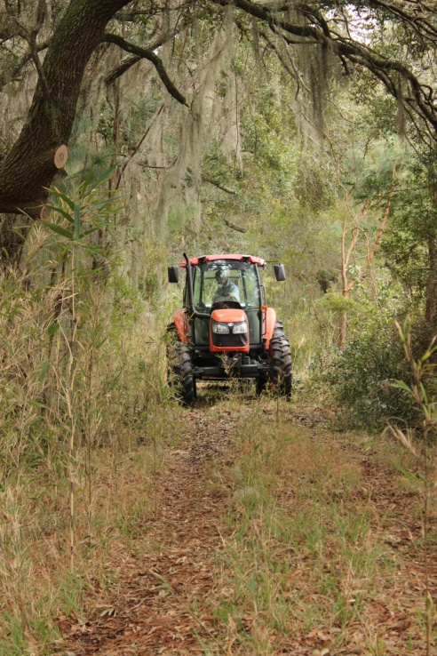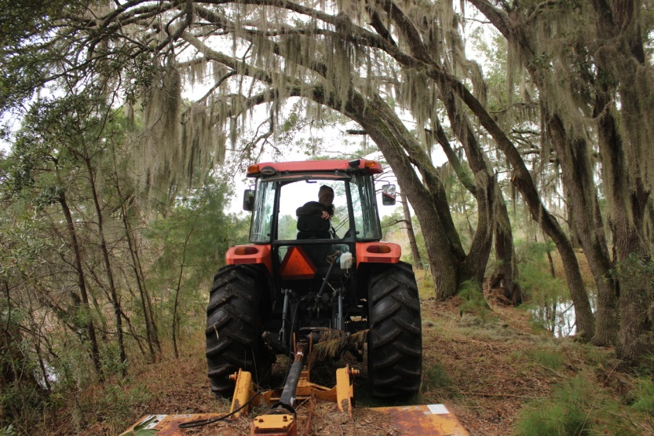
Thank you for giving us several opportunities gain equipment experience!
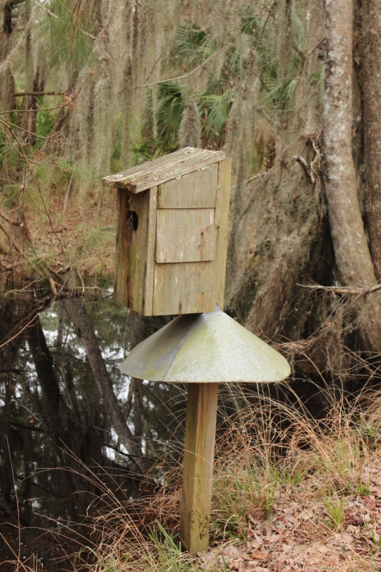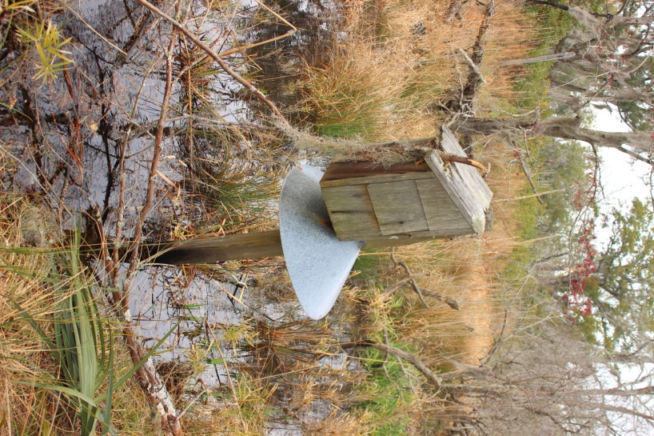
Most of the wood duck boxes around the pond are in good shape, although there are a few that could use some maintenance.

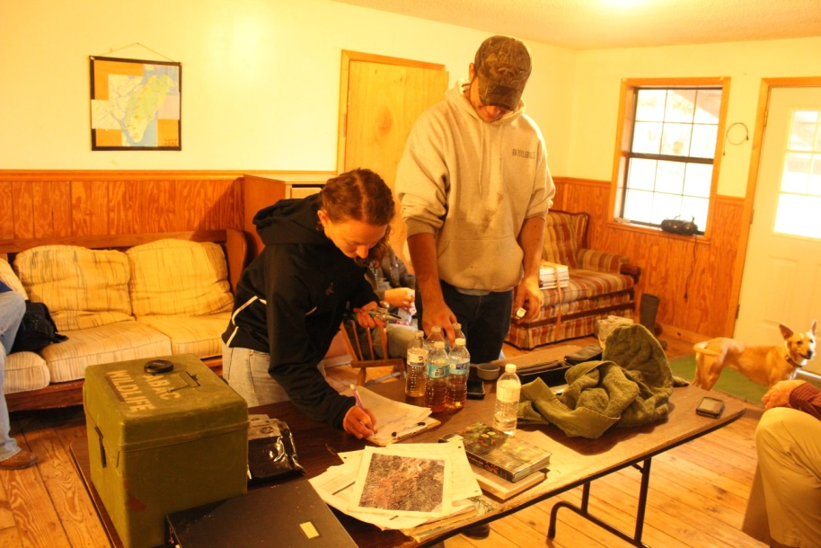
Mr. Fred Hay showed us how to use a refractometer for salinity testing as well as shared with us his goals for the project, and other history of the island.
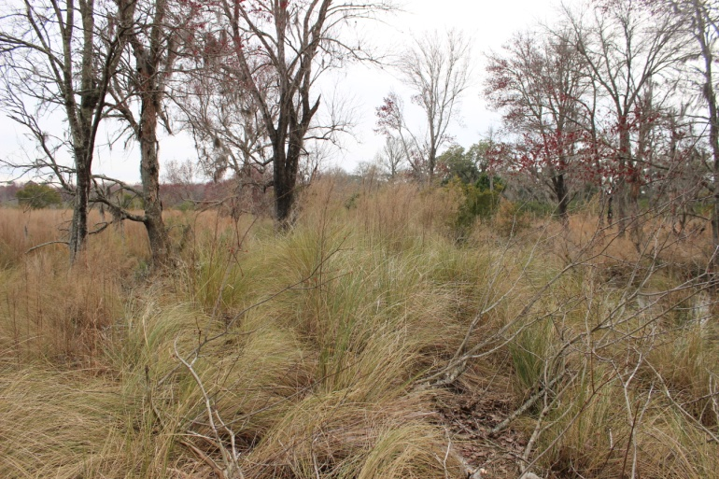
The dike before clearing.
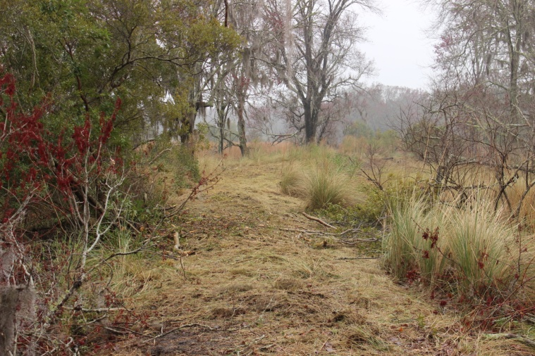
The dike after clearing.
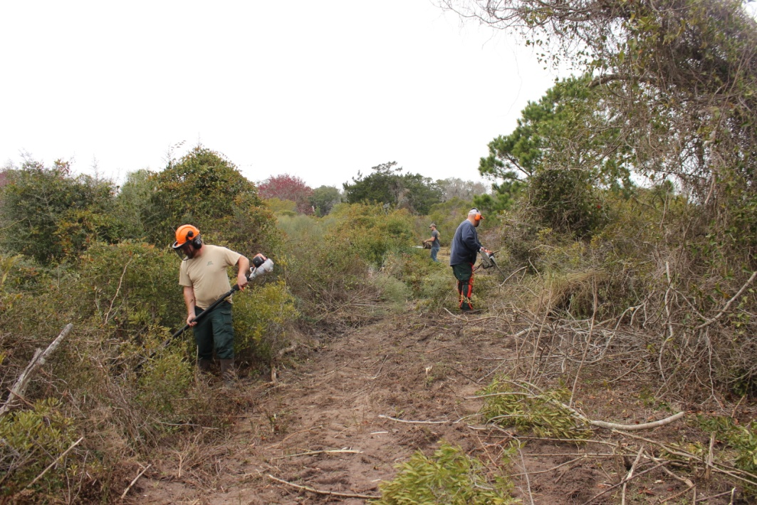
We had several volunteers that made the project possible, thank you for all of your help.

